# Packet Tracer Lab Template
## Lab Title
Logical and physical mode exploration

## Student Name
Lukas Lagnevall

## Date Completed
2025-09-16

---

## Lab Summary

_Provide a brief summary of what the lab was about. What was the goal or objective?_

---

## Reflection Questions

### 1. What did you do in this lab?
Looked at a basic wiring closet and configured a backup router.
### 2. What did you learn?
Learned about various cables and their uses as well as how to do some basic cabling and configuring
### 3. What did you struggle with or not fully understand?
No parts were difficult
### 4. What suggestions do you have to improve this lab experience?
No feedback
---

## Lab Completion Evidence

### 📸 Screenshot: Final Topology
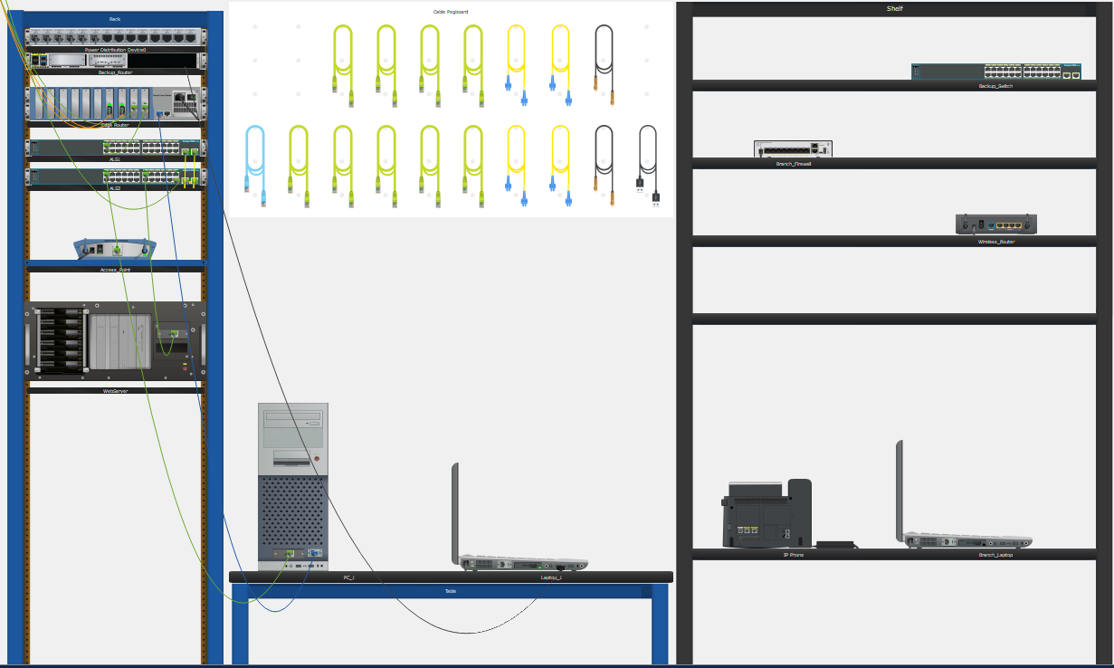
### 📸 Screenshot: Device Configurations
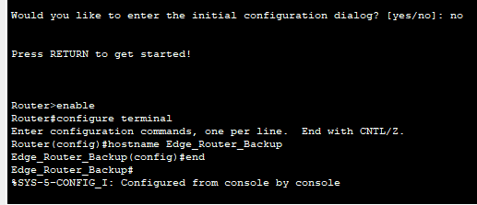
### 📸 Screenshot: Simulation Results
_Insert screenshot showing successful pings, traceroutes, or other simulation results_

---

## Submission Instructions

- Fork the lab repo
- Add your answers and screenshots
- Commit with message: `Completed Packet Tracer Lab`
- Push and submit your repo link in the assignment box

---

© 2025 Sean Ross. Template for educational use.

